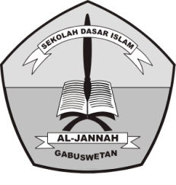**PENILAIAN TENGAH SEMESTER (PTS) GANJIL**

**TAHUN PELAJARAN 2018/2019**

SD ISLAM AL-JANNAH

**Jl. Raya Gabuswetan No. 01 tlp (0234) 5508501**

**Desa Gabuswetan Kecamatan Gabuswetan – Indramayu 45263**

**Email : sdi.aljannah@gmail.com Website :http://www.sdi-aljannah.web.id**

Nama : Hari / Tanggal : September 2018

Kelas :II (Dua) Mata Pelajaran : Bahasa Inggris

1. **Berilah tanda silang (X) pada huruf A, B, C, atau D di depan jawaban yang dianggap paling benar!**
2. The meaning of “garlic” is …

a. Bawang merah c. bayam

b. Bawang putih d. Kol

1. Bayam in English is.....

a. spinach c. tomato

b. pumpkin d. aubergin

1. These are my..... …

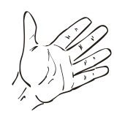 a. hairs

c. hands

b. arm

d. fingers

1. ..........your teeth twice a day.
2. Wash c. open
3. Brush d. Raise
4. .......your hands before eating.

a. brush c. wash

b. open d. raise

1. This is my.....
2. Chin c. Ears
3. Cheek d. Eyes
4. A : Good afternoon, Pipit.

B : ……………, Ayu.

1. Good afternoon c. Good morning
2. Good evening d. Good night
3. What is this?
4.  That is eyes
5. That is eye
6. This is eyes
7. This is eye
8. A : My name is Amel.

B : I’m 9…….

1. Years old c. Thank you
2. I’m fine d. Good morning
3. A : My name is Dzunun.

B : I……….in Karangsinom

1. Life c. Live
2. Years old d. I’m fine
3. Stomach in Indonesia is…..
4. Ibu jari c. dada
5. Perut d. cheek
6. These are my.....
   * 1. Hair c. Hand
     2. Hairs d. Nose

**Rama’s school**

Rama school is big and modern.

It has many facilities

There are 12 classroom, 1 library, 2 teacher room, and 1 headmaster room.

There are also a computer room and a big school hall.

The school also has a medical center and one canteen.

Each classroom has 30 chairs and 15 tables.

Rama’s class has 20 students.

There are 11 boys and 9 girls.

1. What is the title of text above…..
2. Rama’s school
3. Kerin’s school
4. Angie’s school
5. Nixie’s school
6. How many classrooms in Rama’s school…..
7. Eleven c. Thirteen
8. Twelve d. Fourteen
9. How many teacher rooms in Rama’s school…
10. One c. Three
11. Two d. Four
12. How many chair in Rama’s class…..
13. Thirty c. Fifty
14. Forty d. Sixty
15. How many tables in Rama’s class…..
16. Fourteen c. Sixteen
17. Fifteen d. Seventeen
18. How many students in Rama’s class…..
19. Ten c. Thirty
20. Twenty d. Forty
21. How many boys in Rama’s class…..
22. Eleven c. Thirteen
23. Twelve d. Fourteen
24. **Isilah titik-titik di bawah ini dengan huruf yang benar!**
25. 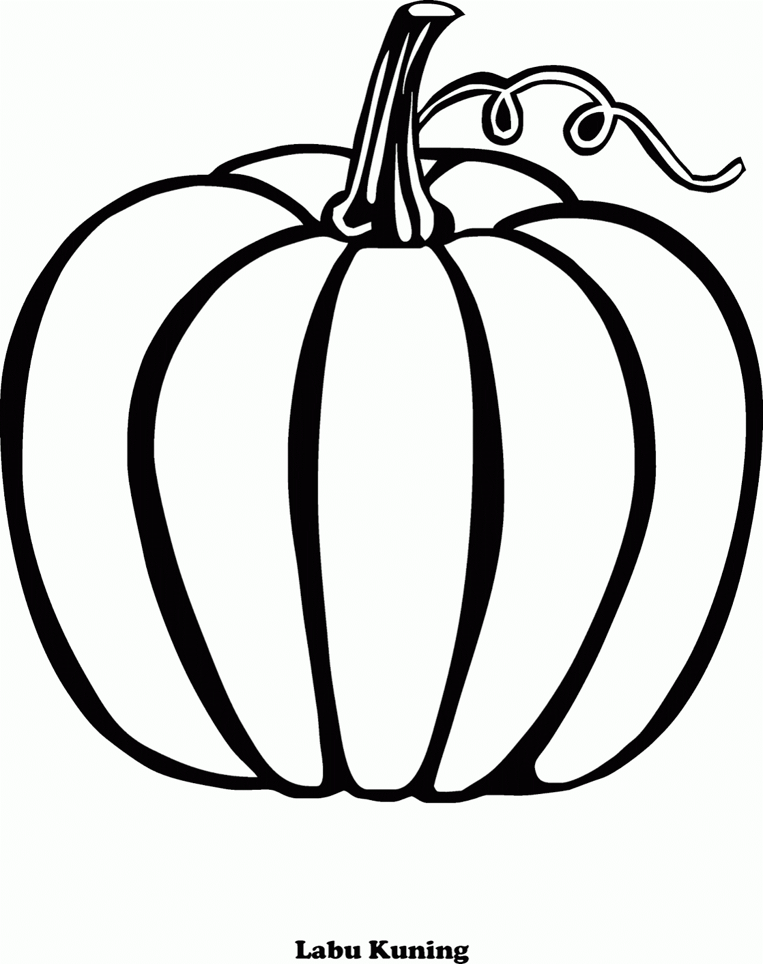

P

i

N

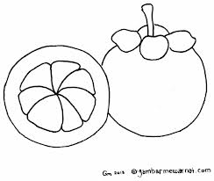

M

N

O

T

N

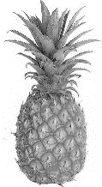

I

N

A

L

E

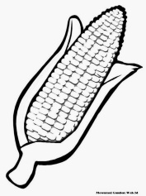

C

R

N

E

E

E

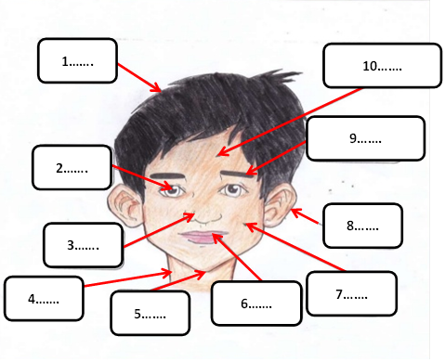

1. **Fill in the blank!**
2. ...............
3. ...............
4. ...............
5. ...............
6. ...............
7. ...............
8. ...............
9. ...............
10. ...............
11. ...............